**Executing a TCP Zeek Script**

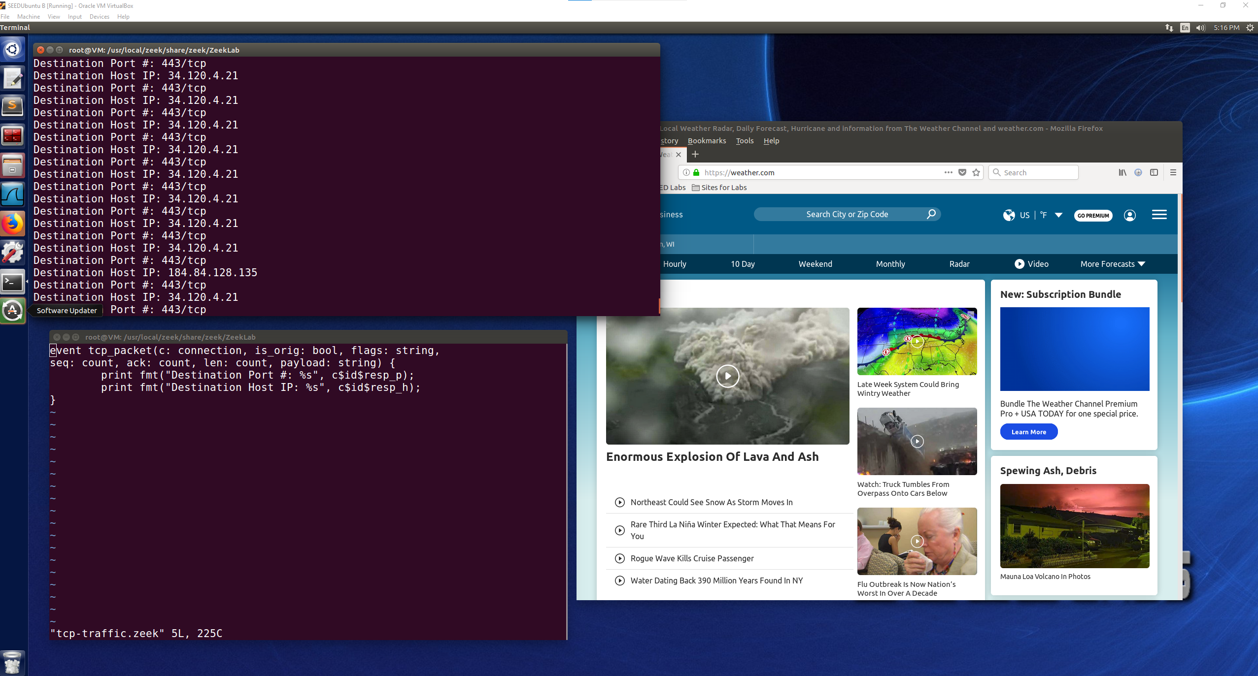

The website I was browsing was <https://weather.com> and the Zeek window(top terminal window) is showing that the destination IP address is that of weather.com. It shows that when browsing there are two different IP addresses being navigated to and that the port being used on this website for this connection is port 443.

In the modified script, the first print fmt line shows that the Destination Port number being printed out through the variable c$id$resp_p and this is seen in the Zeek printout window as 443/tcp. This connection is on port 443 and is a tcp pkt connection. The next print line shows Destination Host IP and is printed out using the variable c$id$resp_h which is the host IP address. This is seen in the Zeek window as printing out Destination Host IP: 34.120.4.21. By using resp_p and resp_h we can gather the destination port and IP information. If orig_p and orig_h was used, then it would be the information of the machine making the request not the destination information.

I attempted to determine what script adjustments I would need to also print out the sequence number but in the Zeek guide I was only able to find get_resp_seq which I could not figure out how to use it when entering it into my script without producing an error. If c$id$resp_h with %d to produce an integer printout, it would become a formatting error due to that variable being a string representation. I was unable to find any guidelines on where to find information on this script modification in the lecture slides unless I overlooked that portion of the slides. I tried to add in the get_resp_seq at various location but couldn’t seem to find the right location for it that would not produce a segmenting error when running the zeek script. Below are examples of what I did try when encountering these errors:

print fmt("Seq: %d", get_resp_seq);

print fmt("Seq: %d", c$id$get_resp_seq);

The next method I tried was to add in the uid of the connection so that the connection could still be traced. I am not sure if this is what the intention of this task was asking for, but it is a solution that I was able to get working to demonstrate that the uid could be added into the printout of information when the zeek script was running. This is shown below where the destination IP, port, and uid are shown.

This shows that the uid of the connection can additionally be added to the output of the zeek script during the web browsing with no errors encountered.

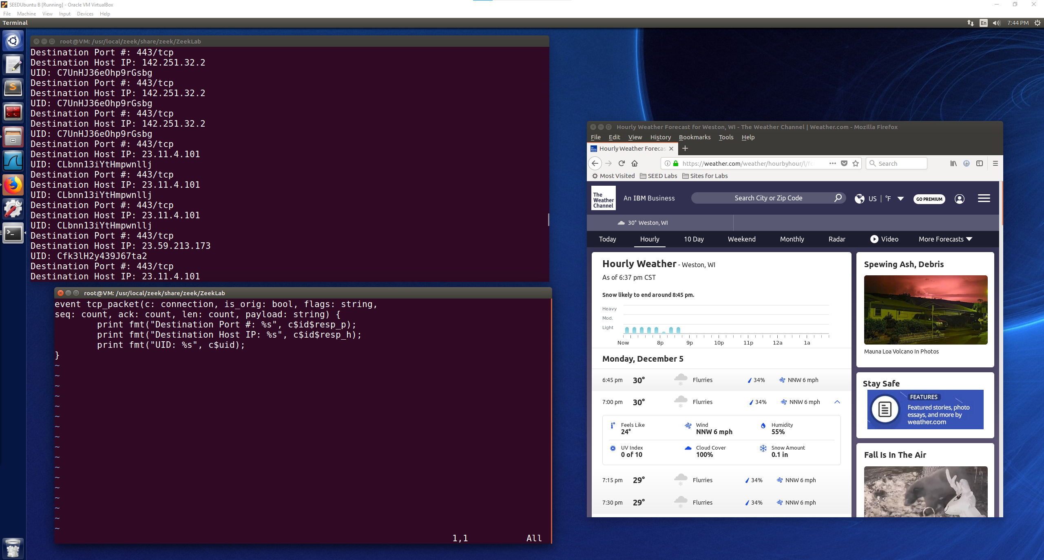

**Modifying Zeek log streams**

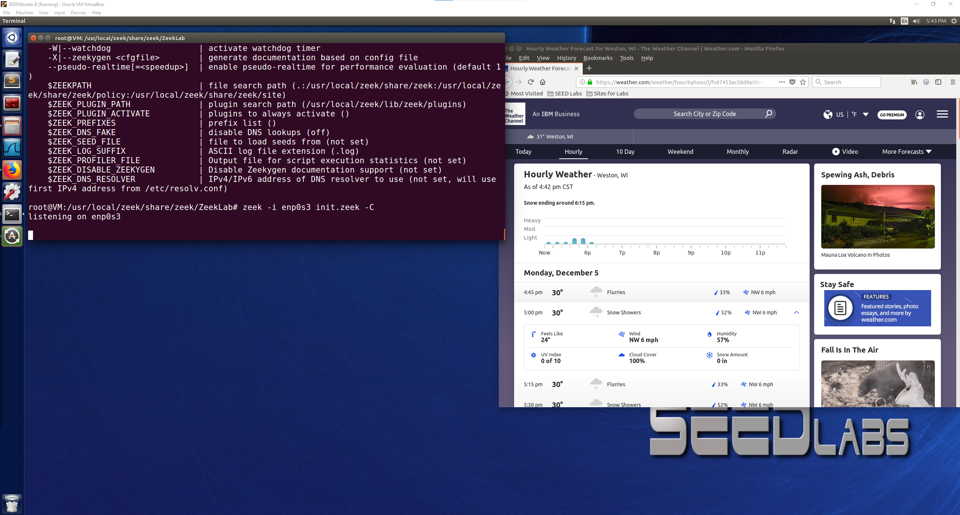

Browsing <https://weather.com> again with the init.zeek script running.

Showing the contents of the UpdatedConn.log file located in the ZeekLab folder:

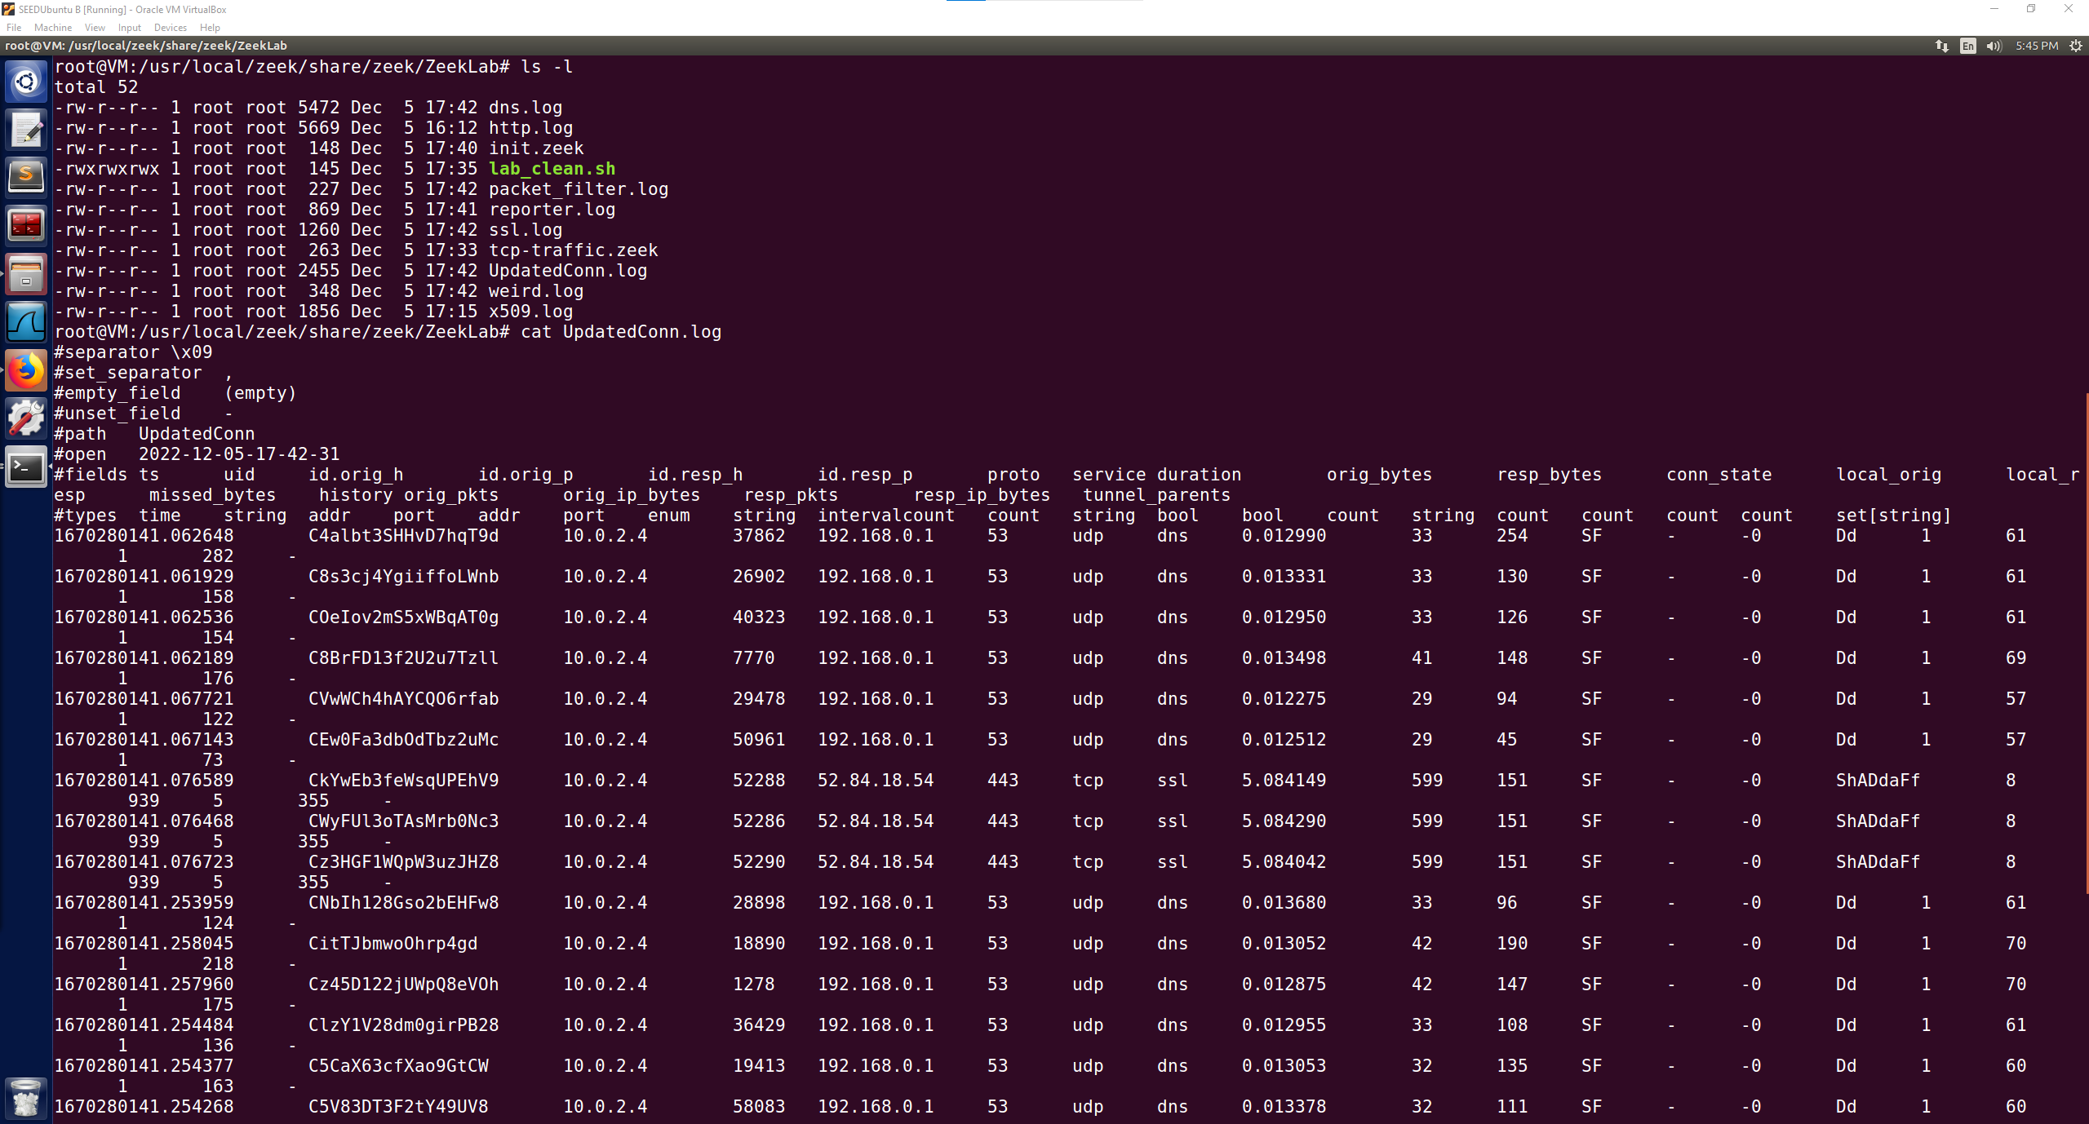

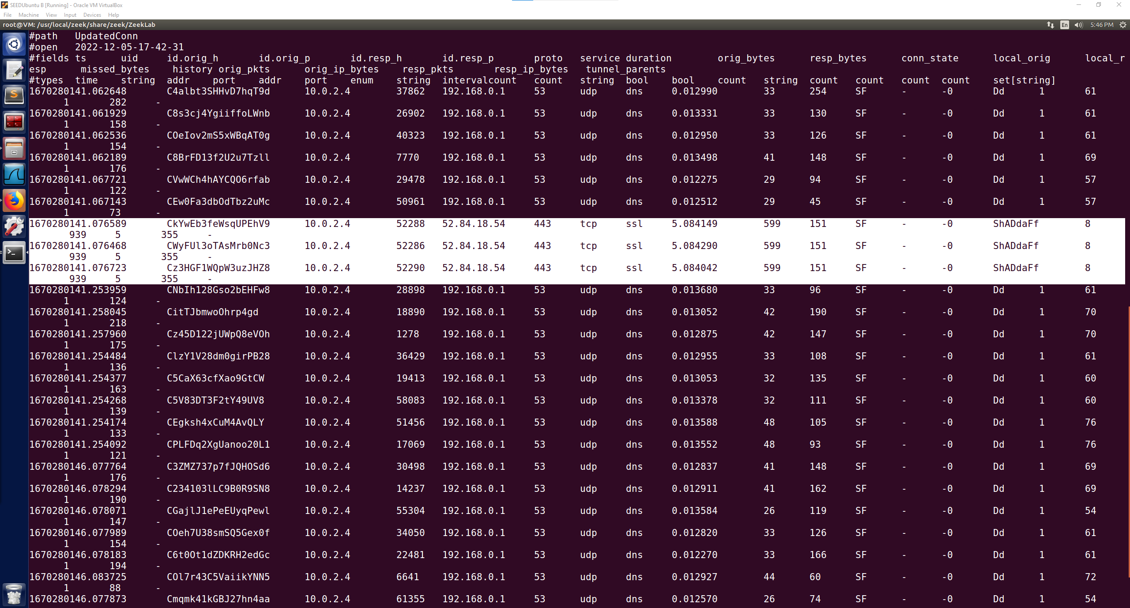

This screenshot above shows the connections to the weather.com website that I was browsing, when the website was connected to it shows the destination IP address of 52.84.18.54 and that port 443 was connected to. Also shown is ssl which means that there is a secure connection the website, this can further be confirmed because the website is an https connection, not http which means there is an authenticated certificate. These connections also are attributed with SF which means that this connection is considered a “normal establishment and termination”. This just means that my connection was normal and that the termination of the connection was also normal, there were no abnormalities about how the system was connected/terminated to this destination host.

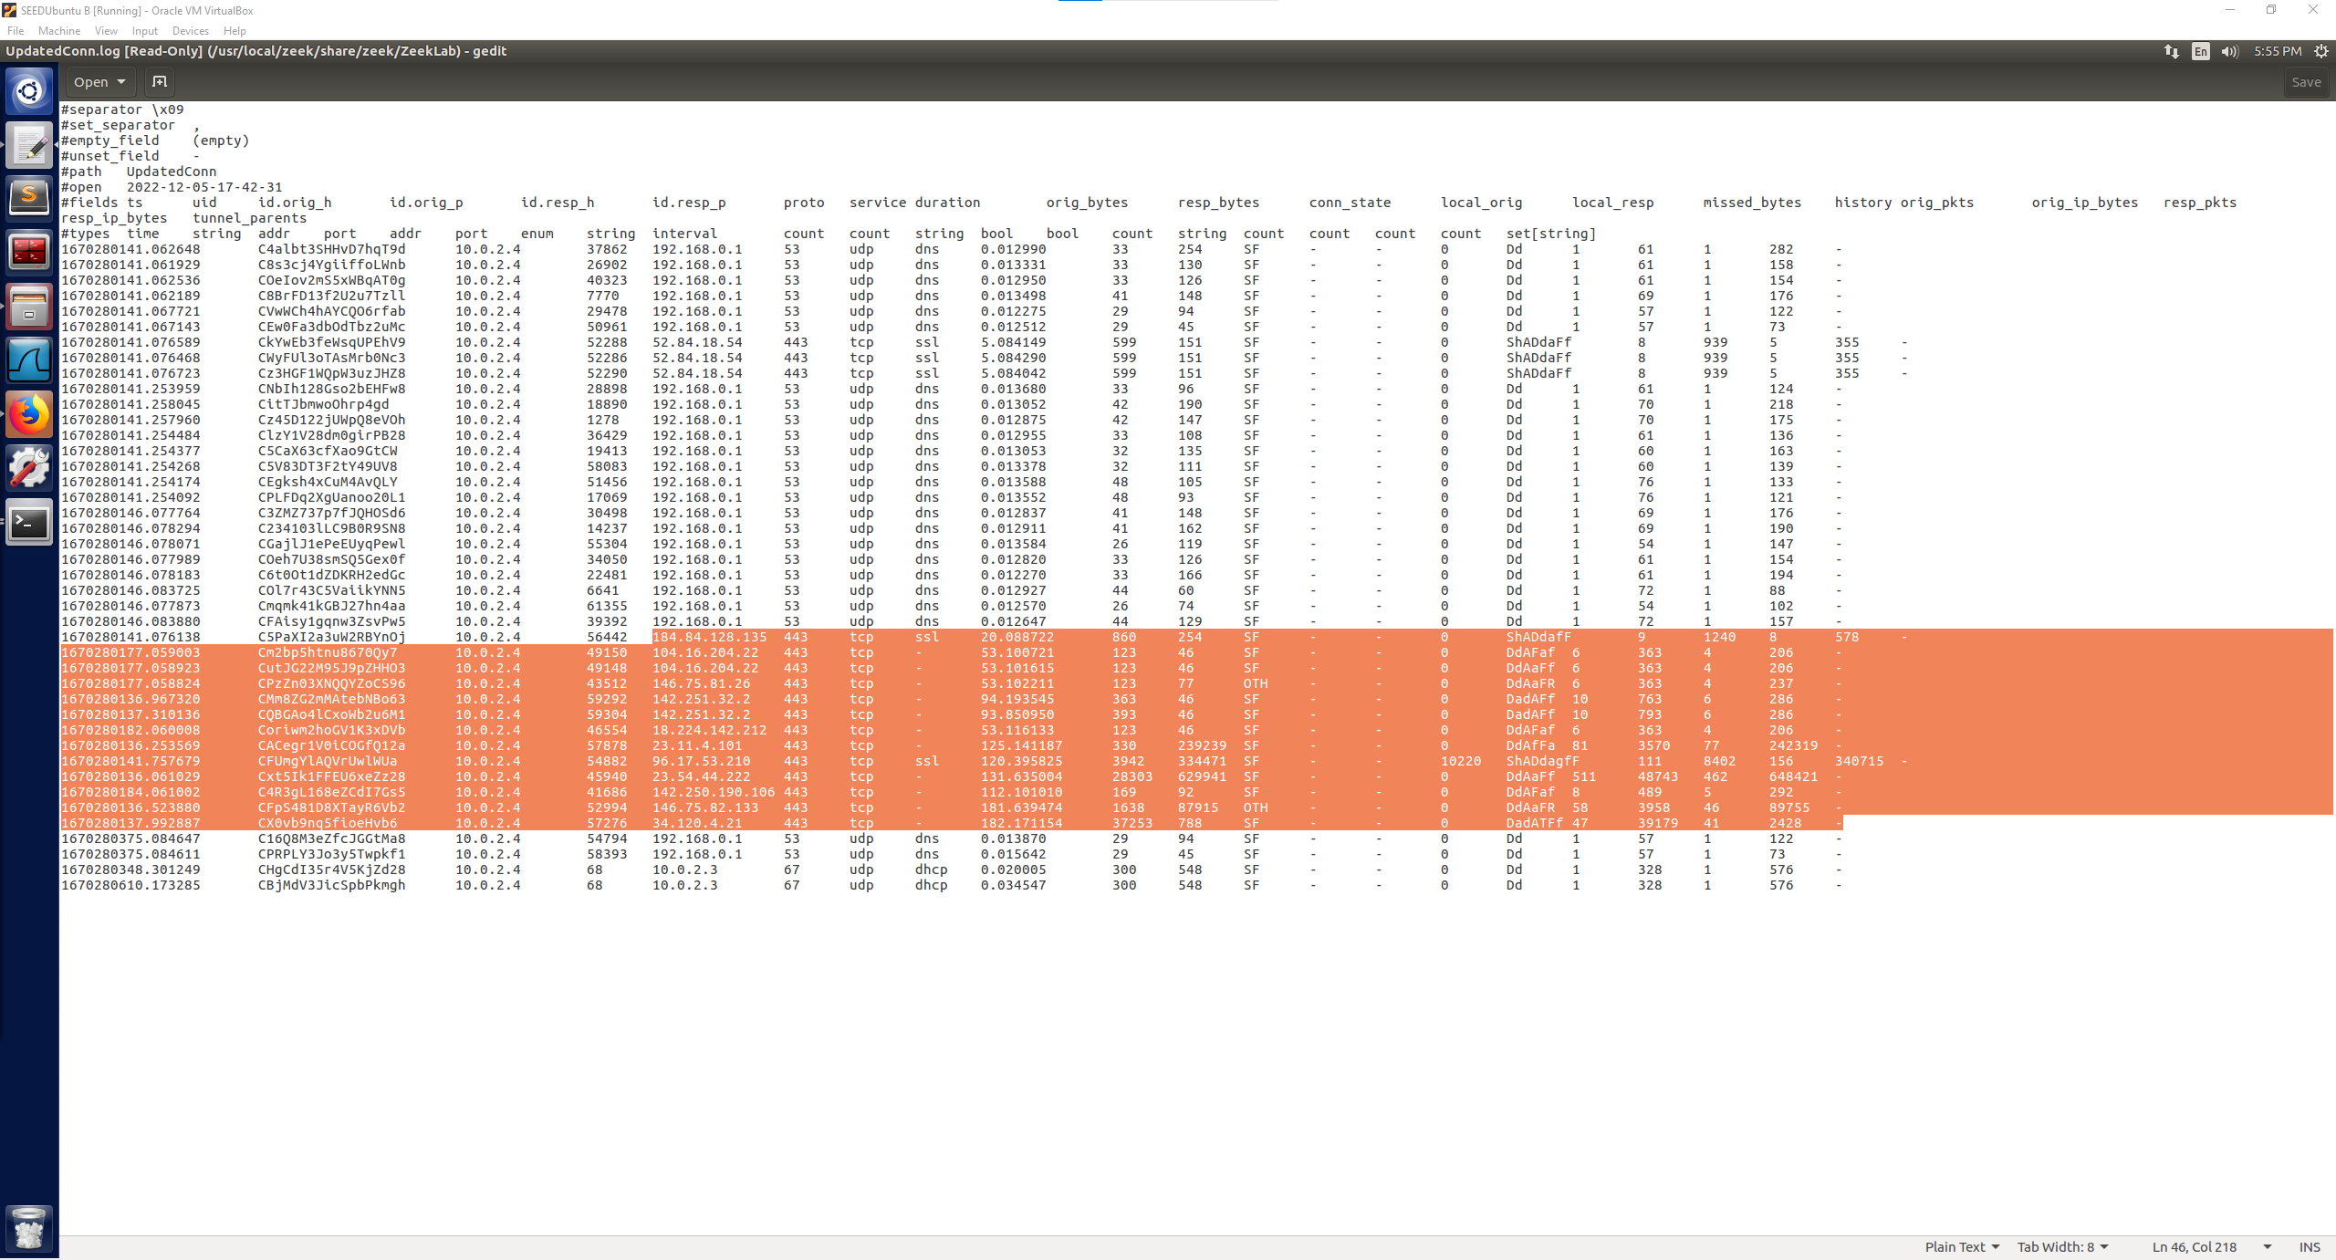

Similarly looking further down the file, other browsing activity was also collected through tcp connections also using port 443. OTH means that there was no SYN seen and that it is just midstream traffic which can be attributed to a partial connection.

Additional with this information the UID is given for each connection which can help to trace the connection across different logs that are collected by Zeek. The originating port is also given for these connections coming from the IP address of my VM. The timestamp(ts) could also be useful information for when the connection was established but is represented as a very large number. The orig bytes and resp bytes also show how many bytes were sent out in the packet and how many bytes were received by the host. That is the information from this log attributed to my web browsing that I can understand from this log, there is more information than just that included in this log, but most importantly I am able to see when my connections took place, the ports used, the destination IP address, protocol, and if ssl was used along with what the connection state is logged as.

**Updating the conn.log stream**

Browsed websites:

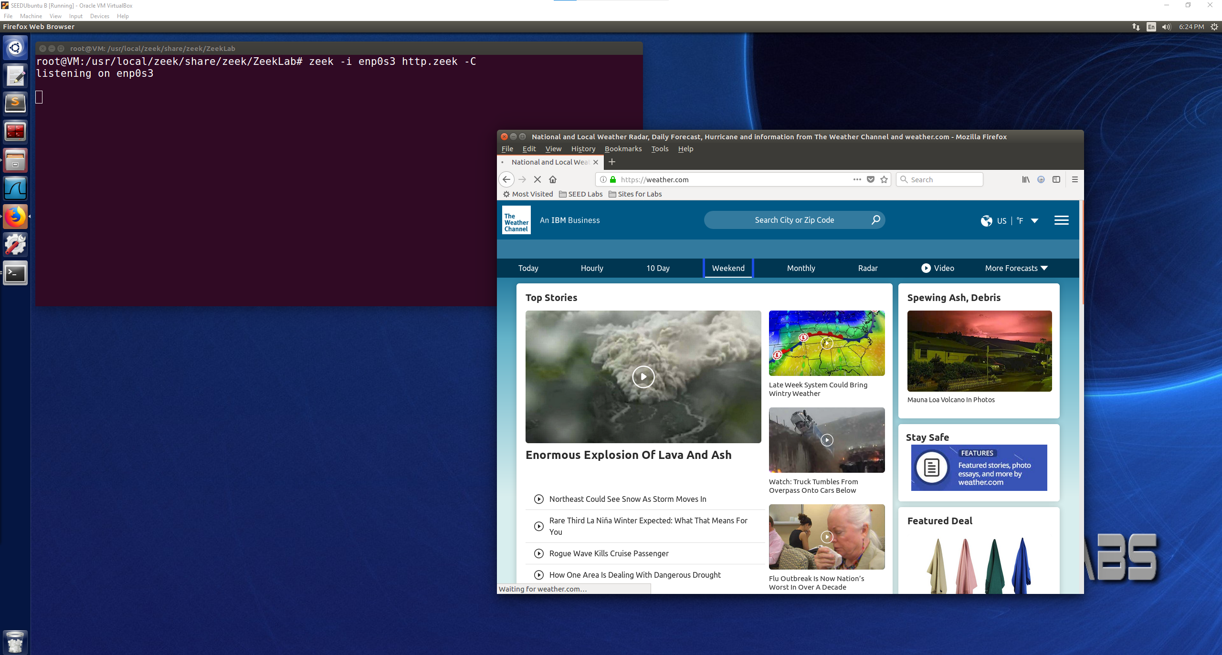

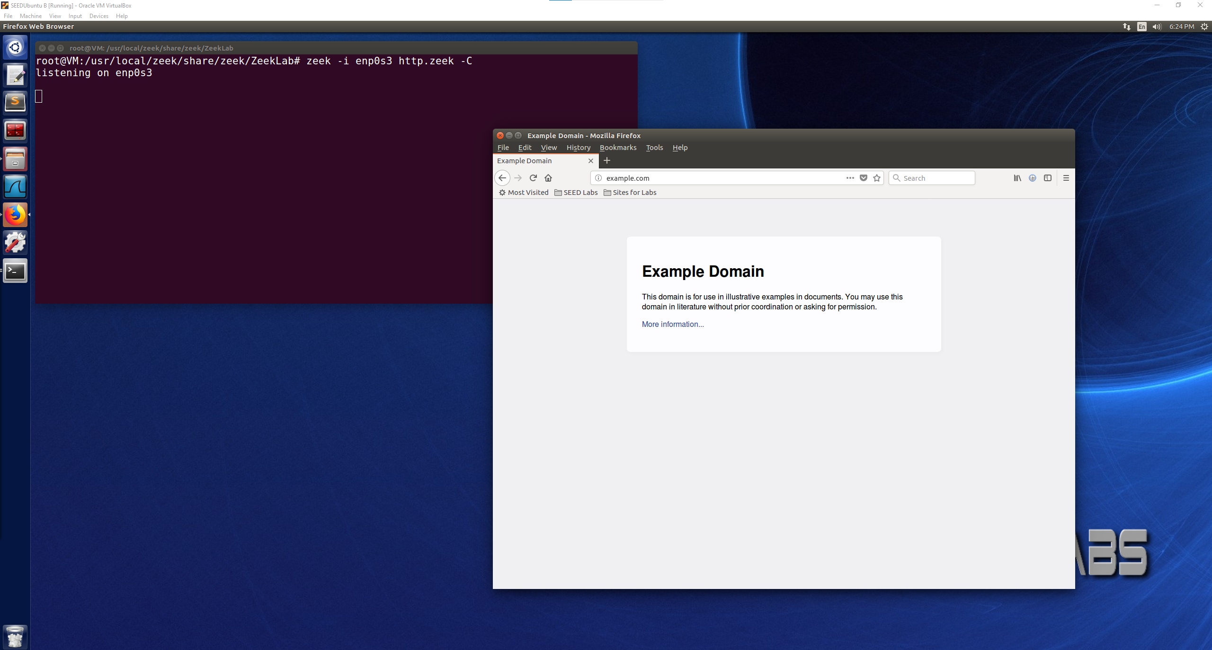

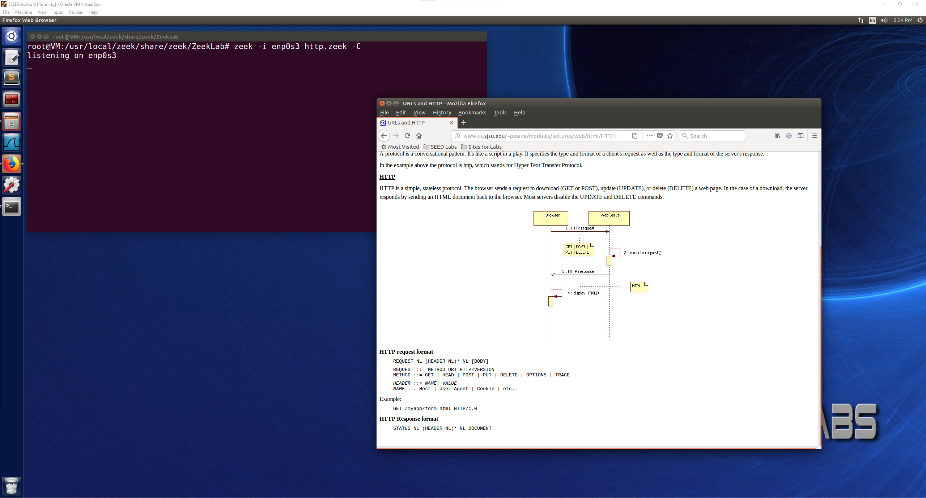

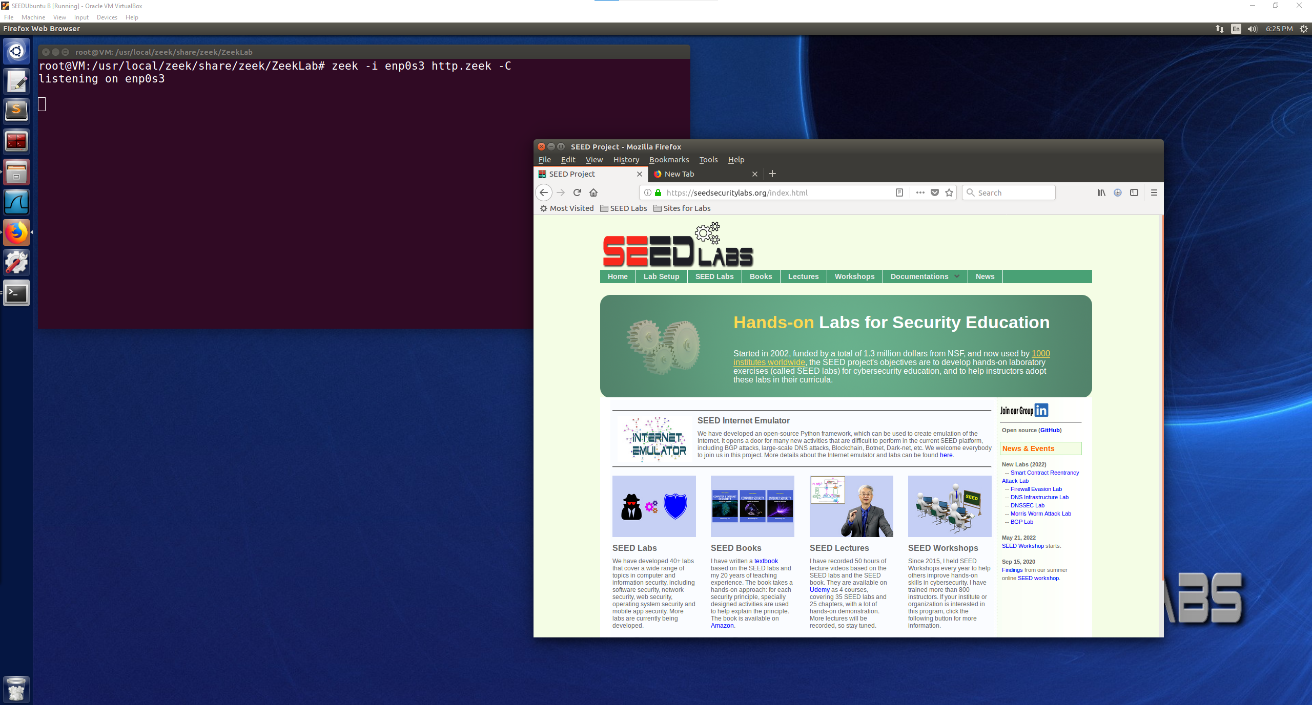

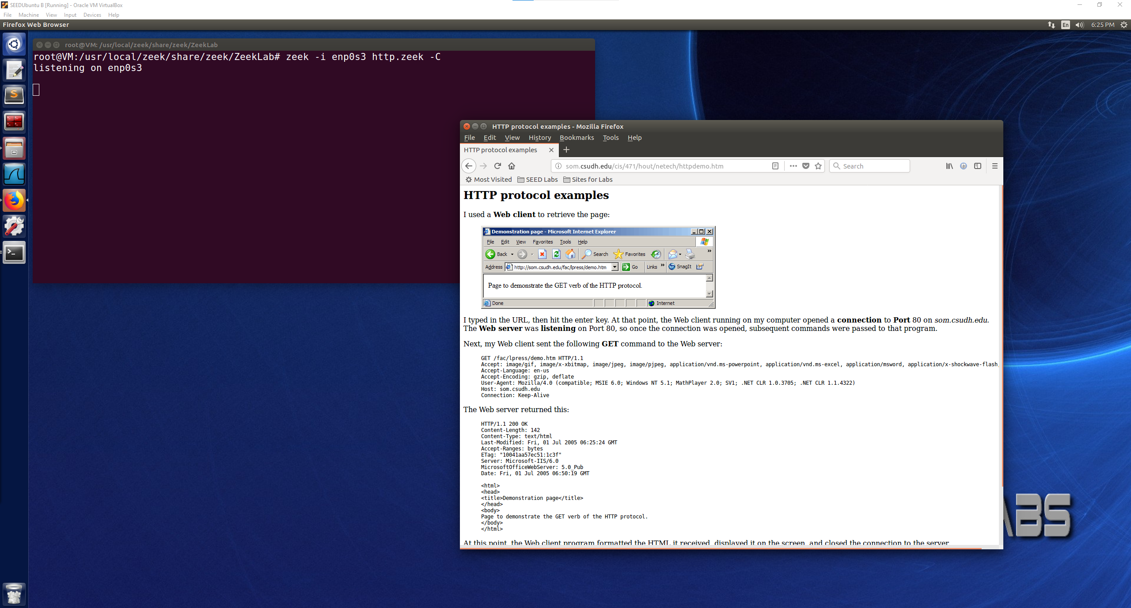

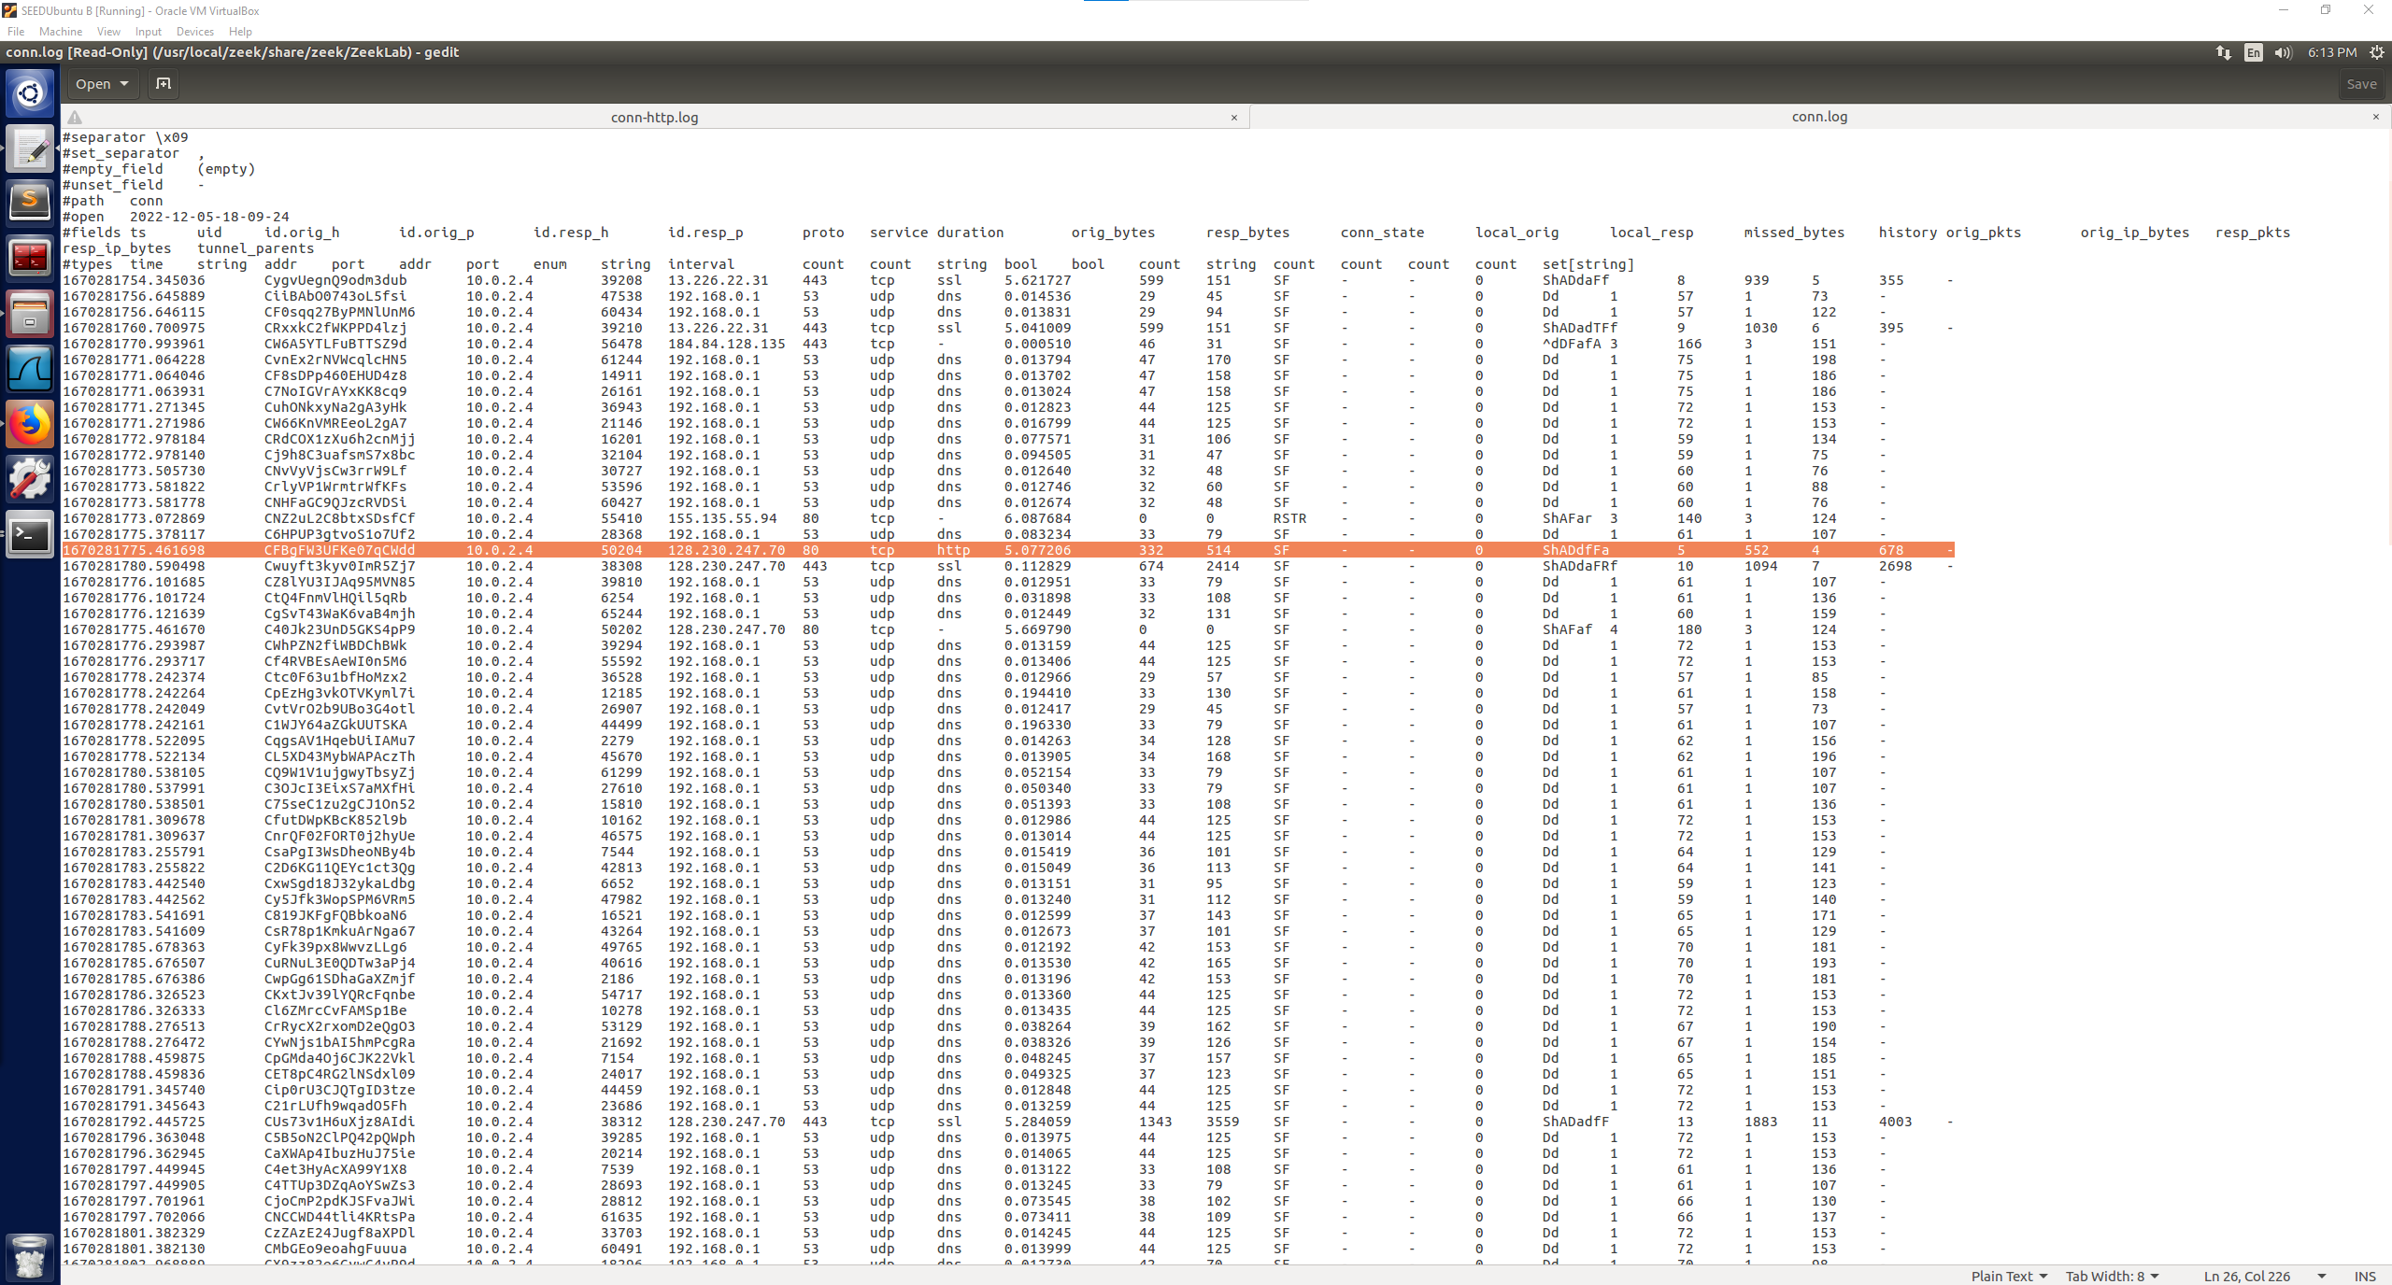

As pictured above, in the conn.log, the highlighted connection is a http connection, the following screenshots also show more http connections that were logged during the website browsing.

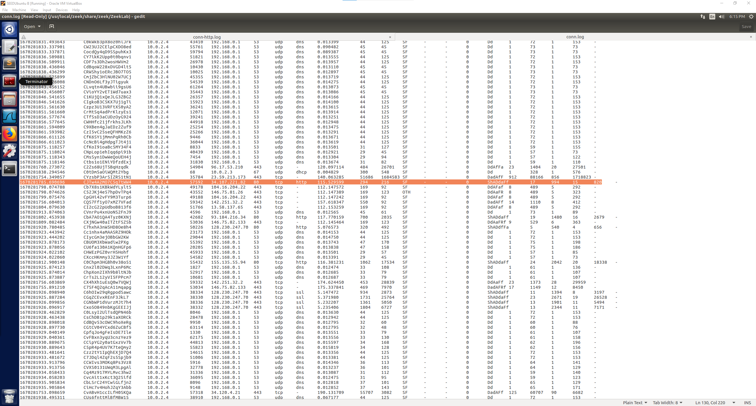

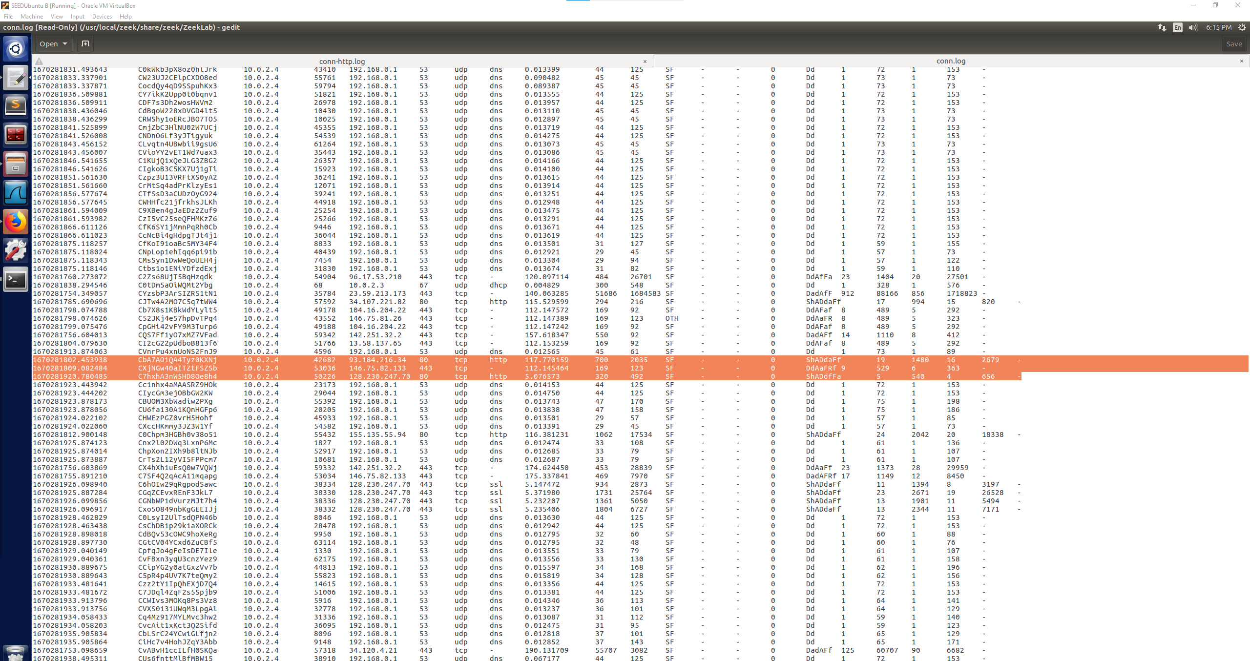

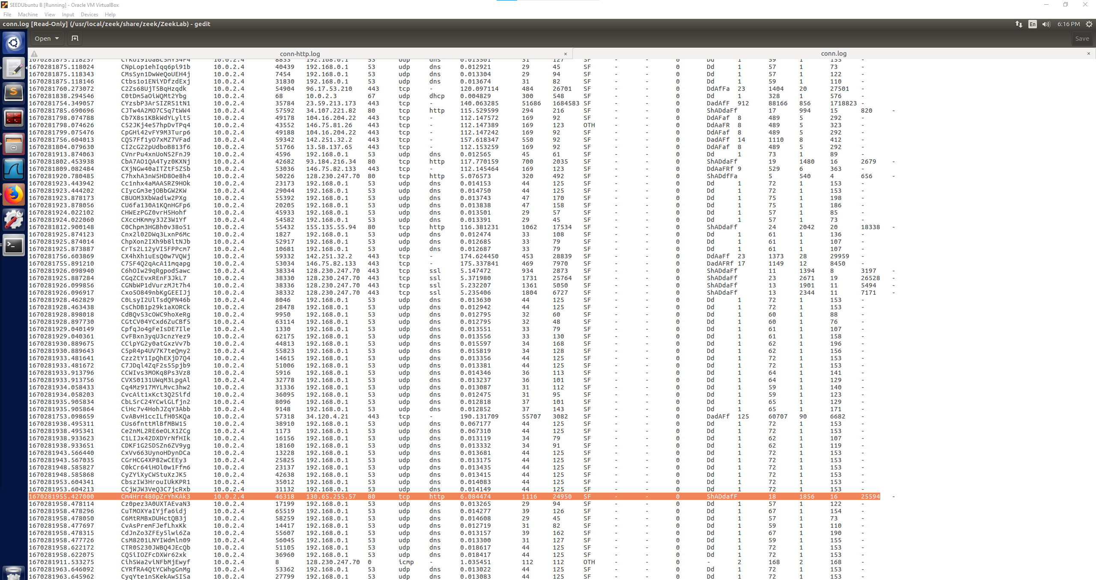

There are also some ssl connections logged which would again be connections to https websites. As pictured below:

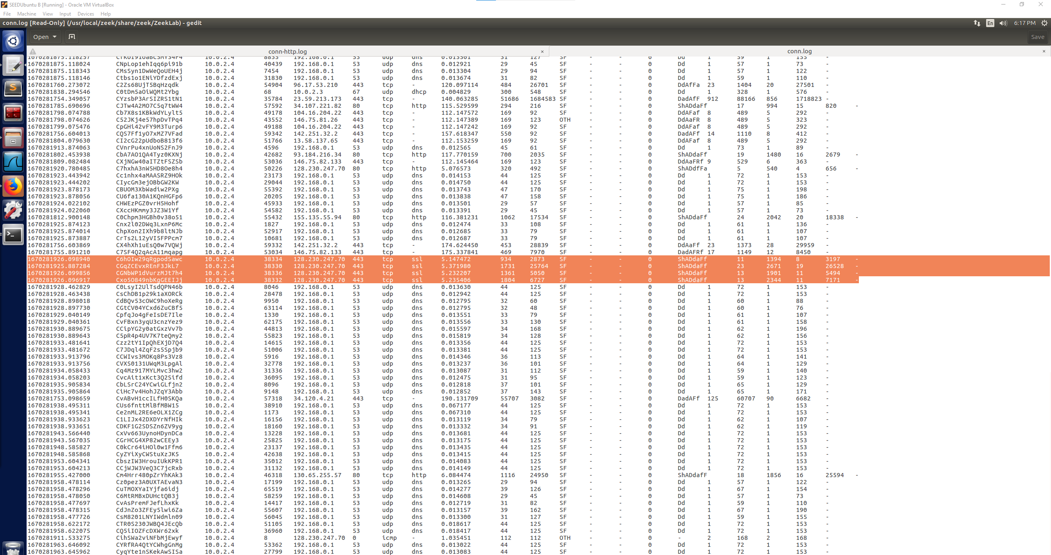

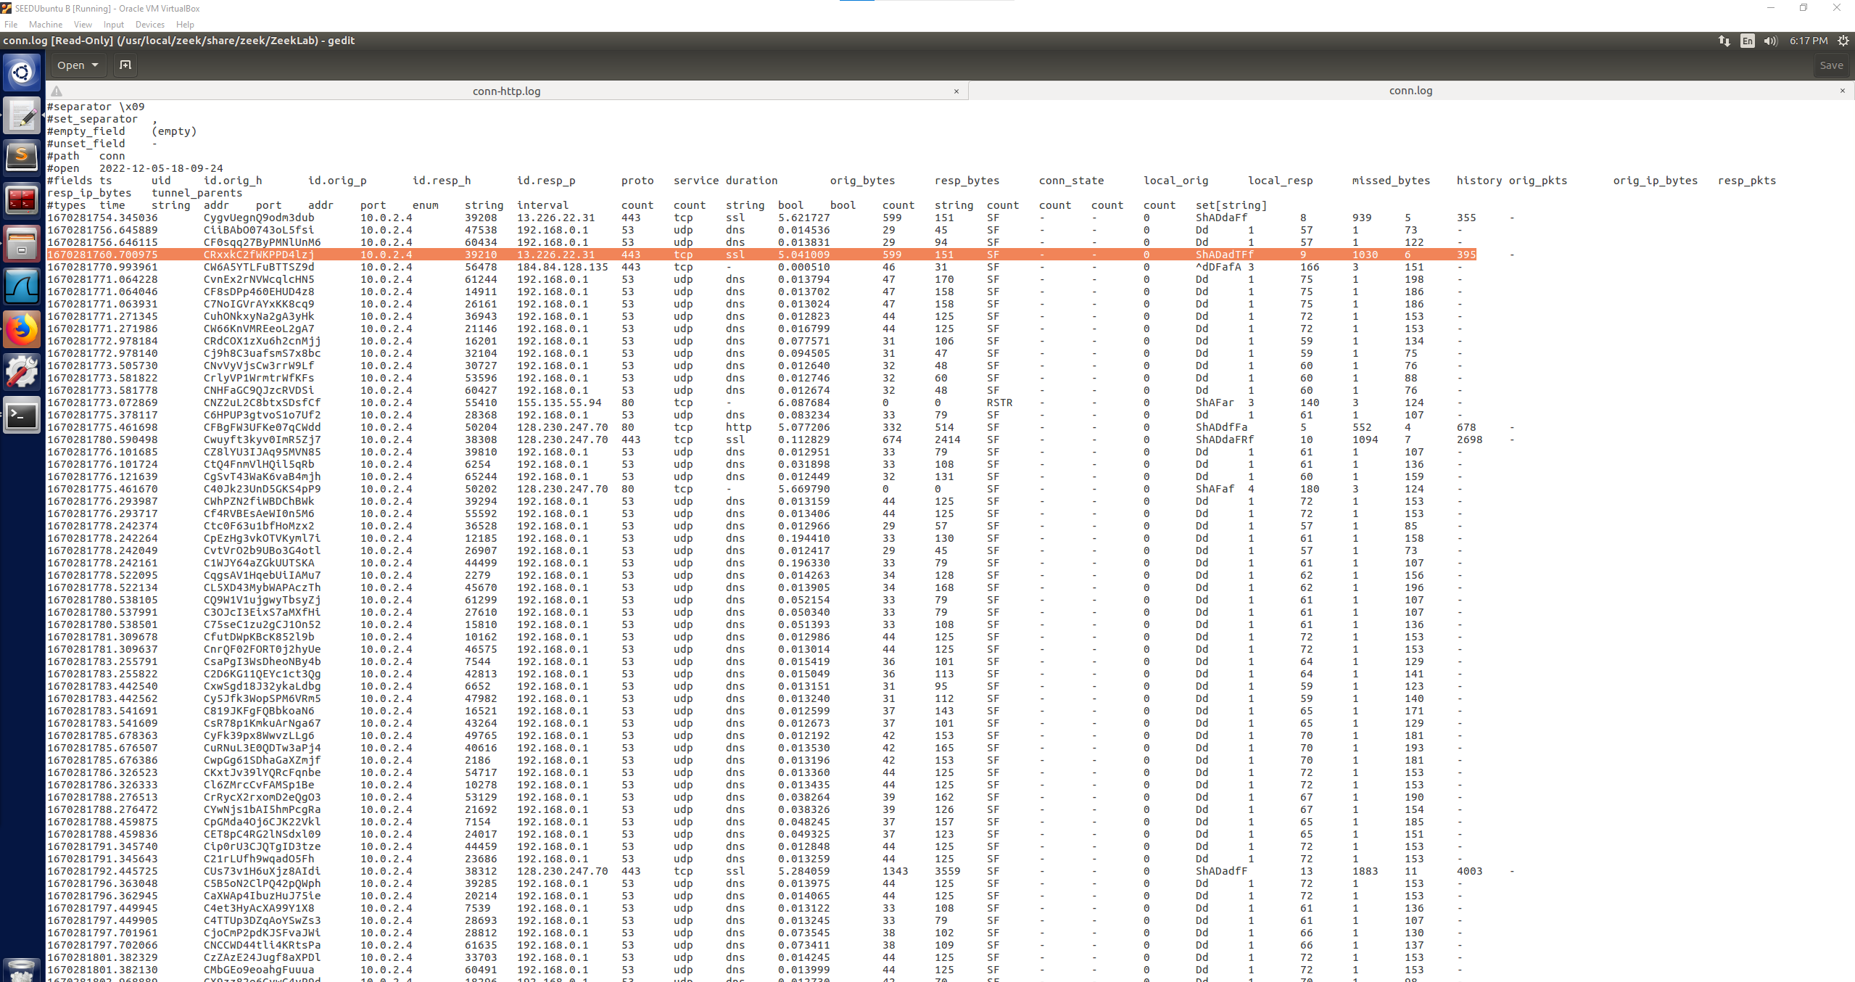

These connections that are highlighted all provide the information previously discussed in the lab task with the UpdatedConn.log, this time there is a distinction shown between the http connections and https connections. When browsing through the conn-http.log, only the http connections are logged and shown.

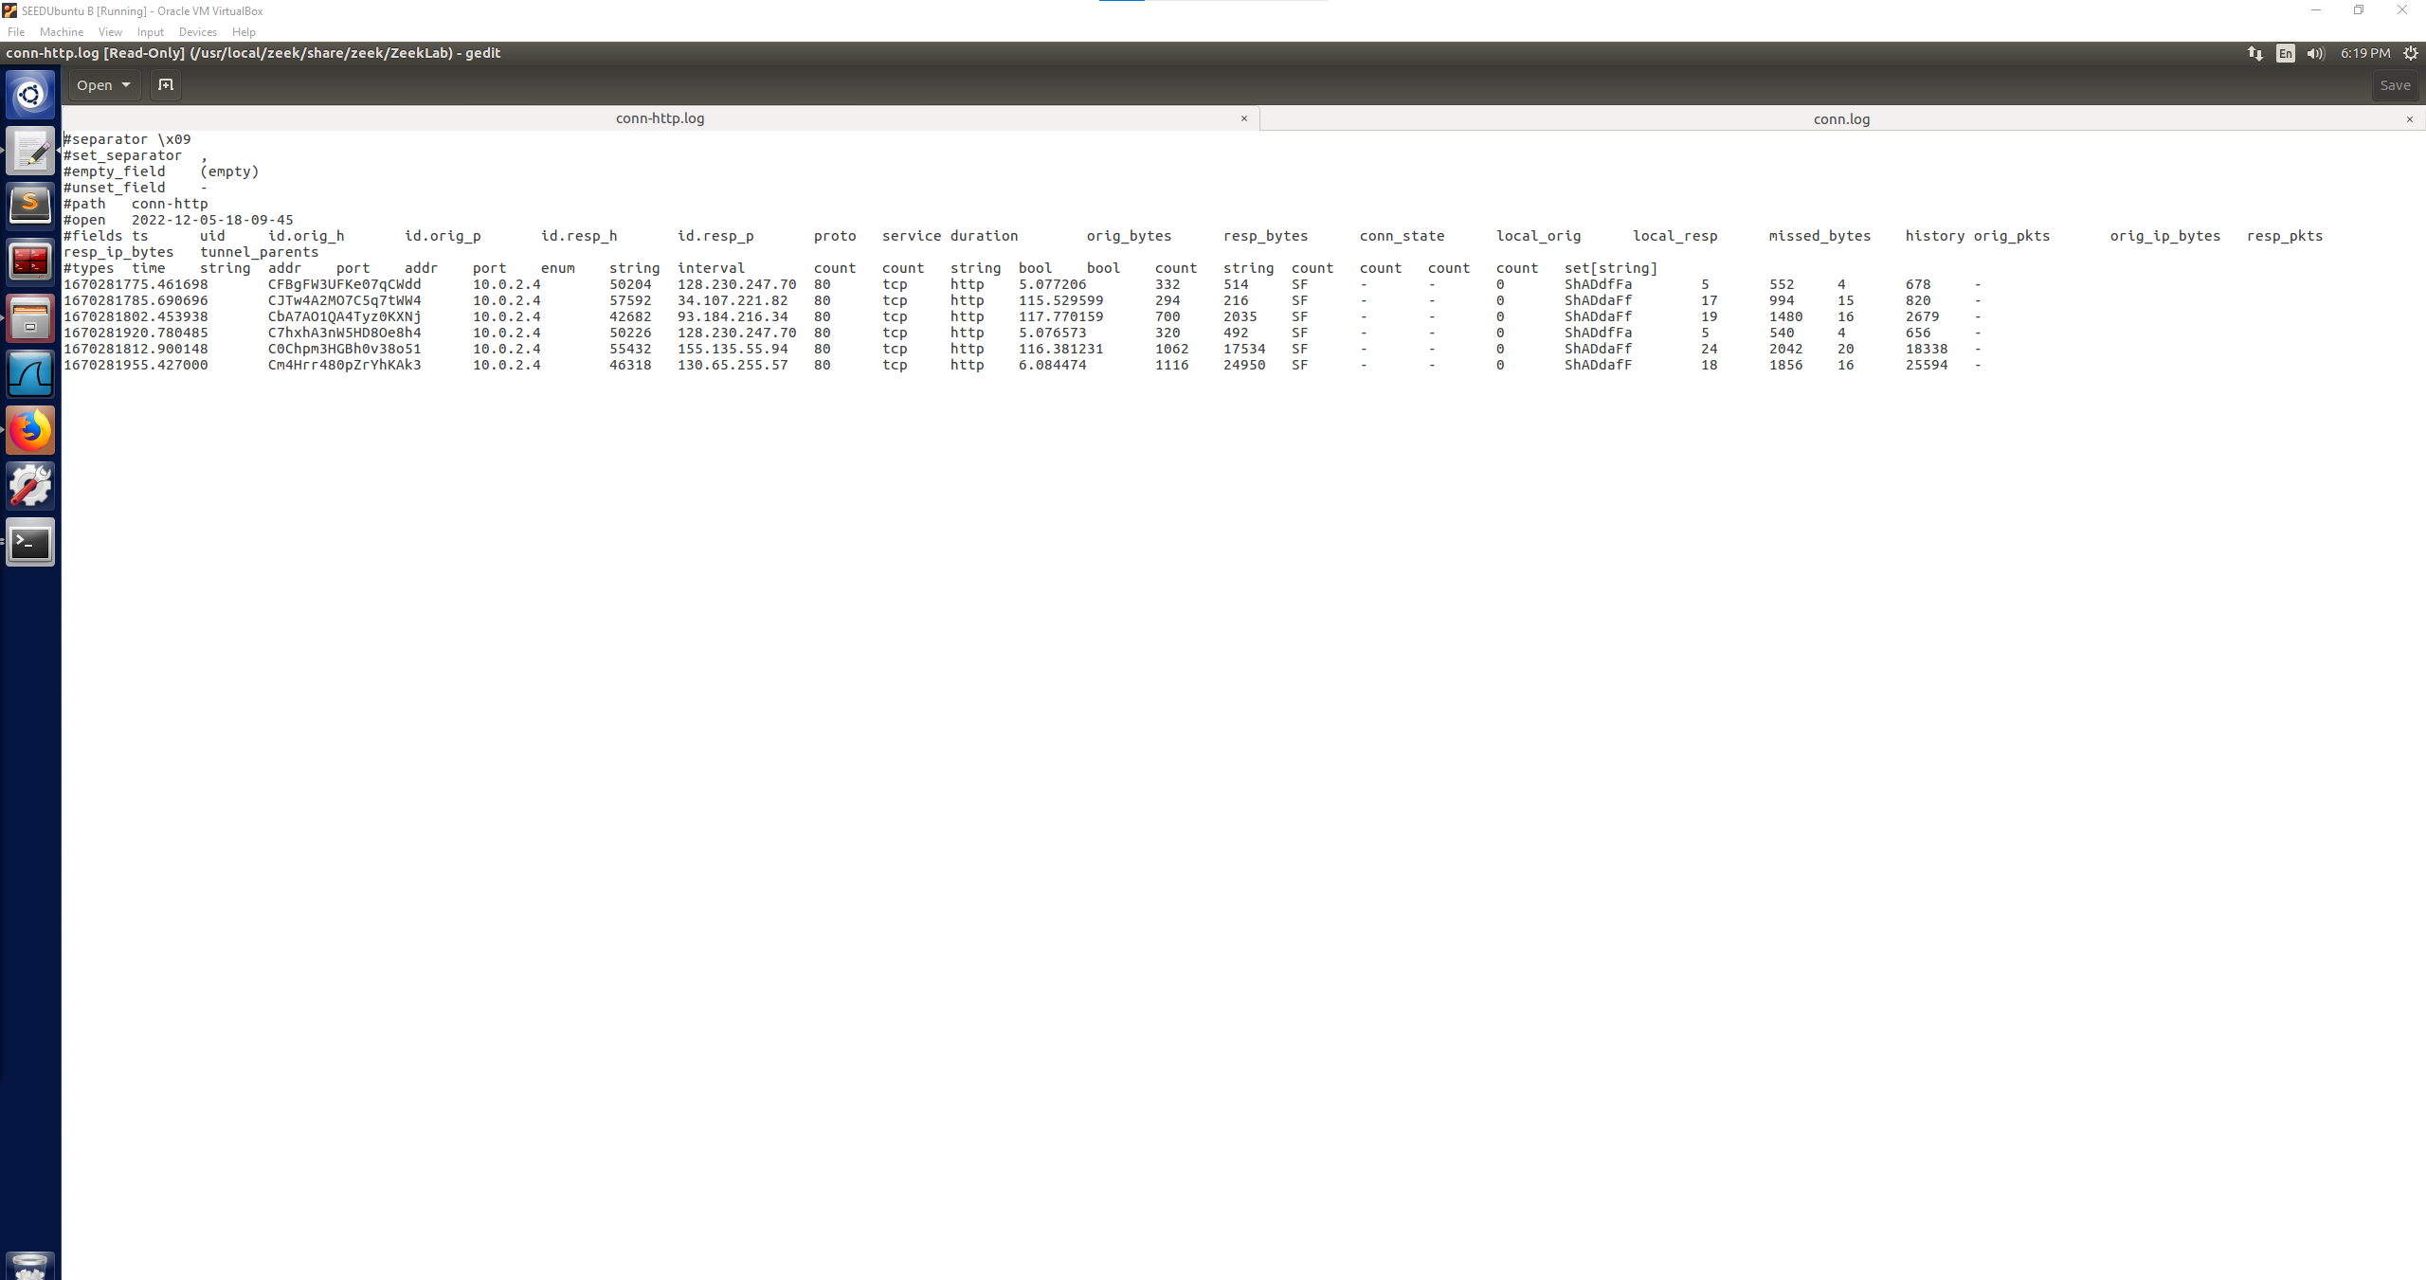

All of these connections shown are http connections from my browsing and show the IP addresses of the websites that were browsed with an http connection. This is an important example of using a Zeek script to gather only the intended connecitons that you want to analyze. The conn.log shows all connections and would be much more work to find specific connections if the script was running for a long duration of time. Whereas, you could run a script to collect only the connections you are curious about in a much cleaner log file. These connections show the source and destination ports as well as the IP addresses for both systems involved, all these connections were using the source port 80. These connections were also labeled as SF which means the were normally established and terminated.

By using the different logs we were able to separate out the http traffic into a cleaner log file rather than searching through all of the connections to find a few http connections. This would save time when looking for a specific connection type like http vs https to see what IP addresses were browsed to that were http.

**Zeek Signatures**

http websites browsed:

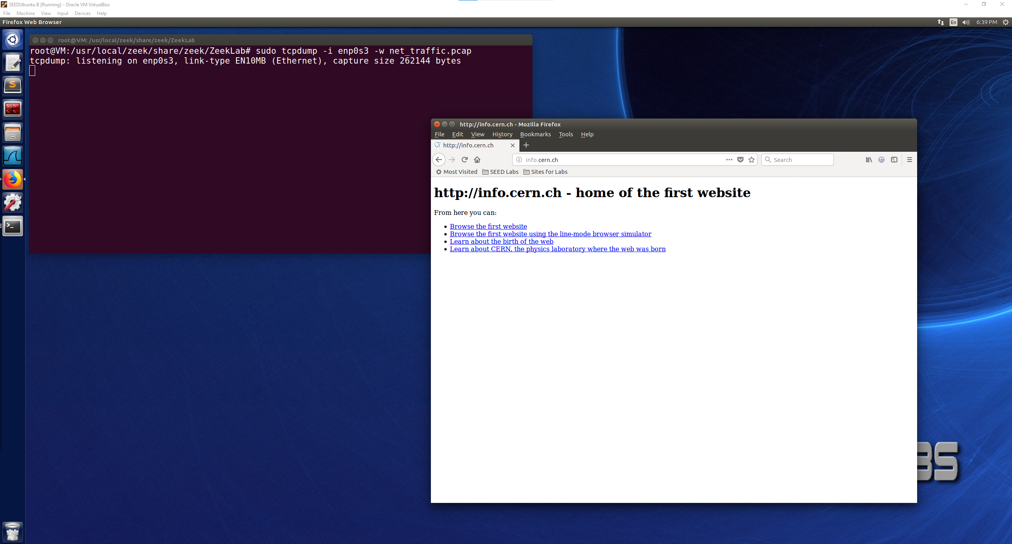

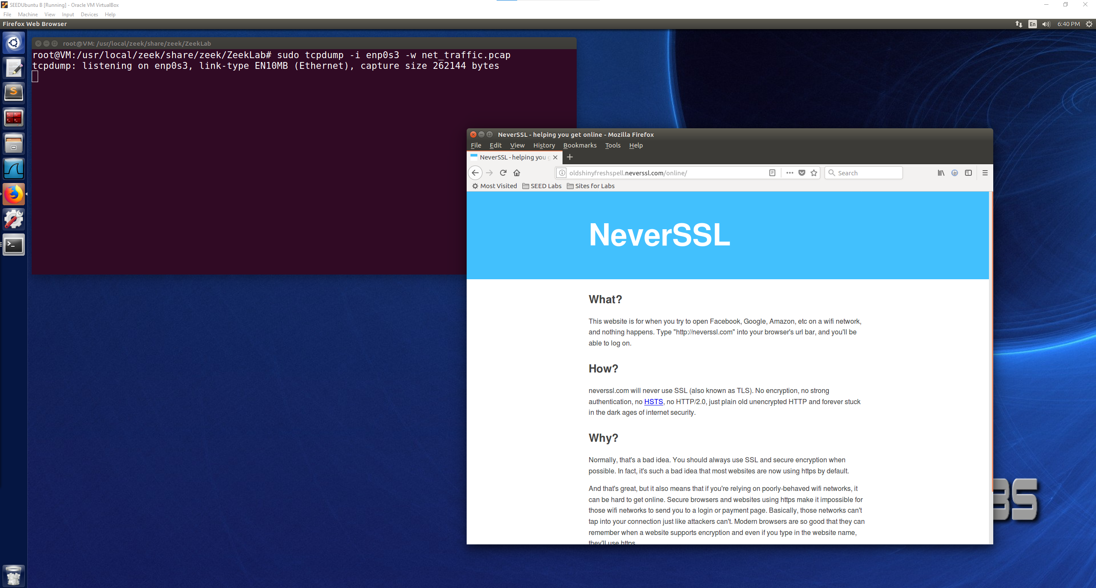

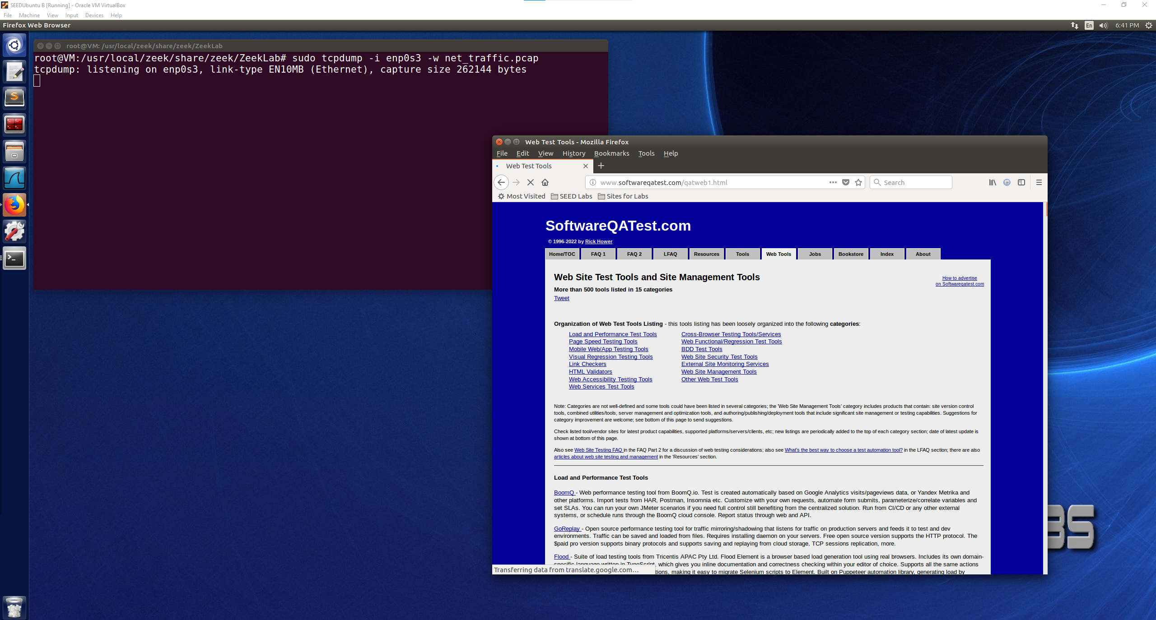

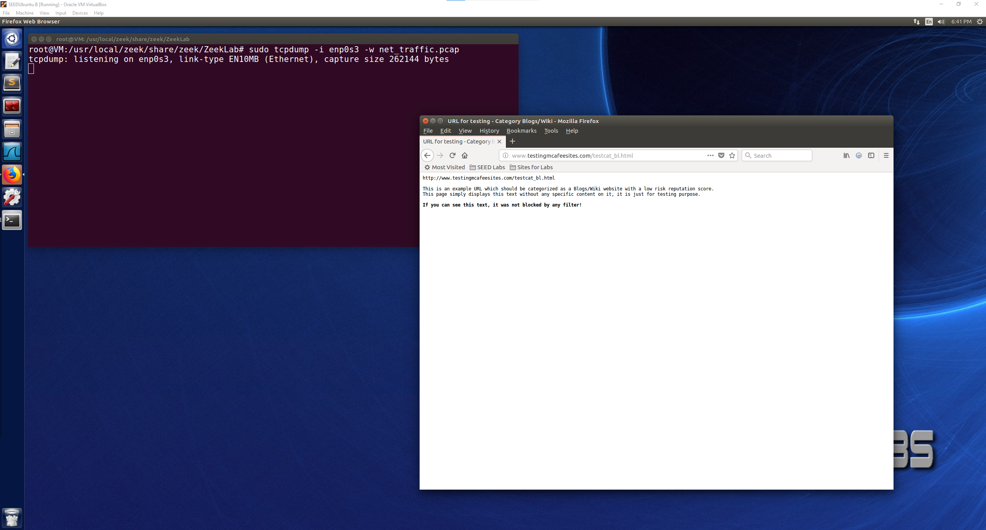

Showing signatures.log file was generated using the command given:

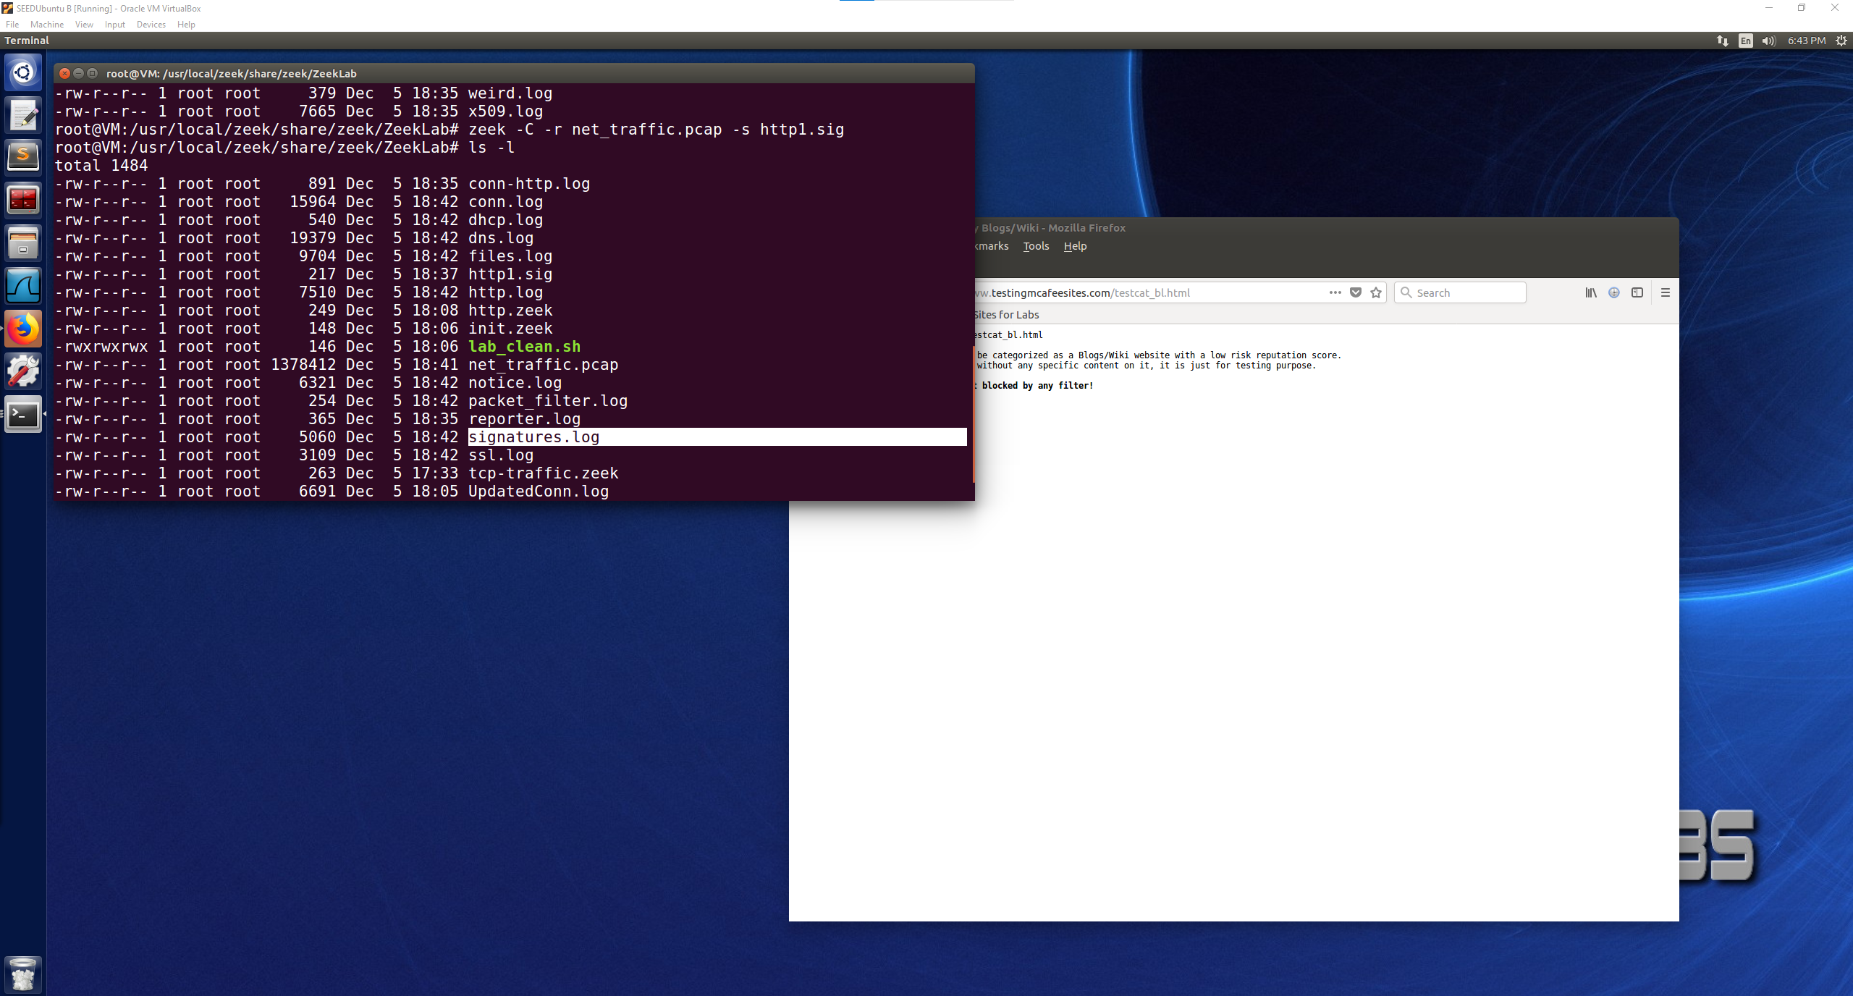

Contents of signatures.log file:

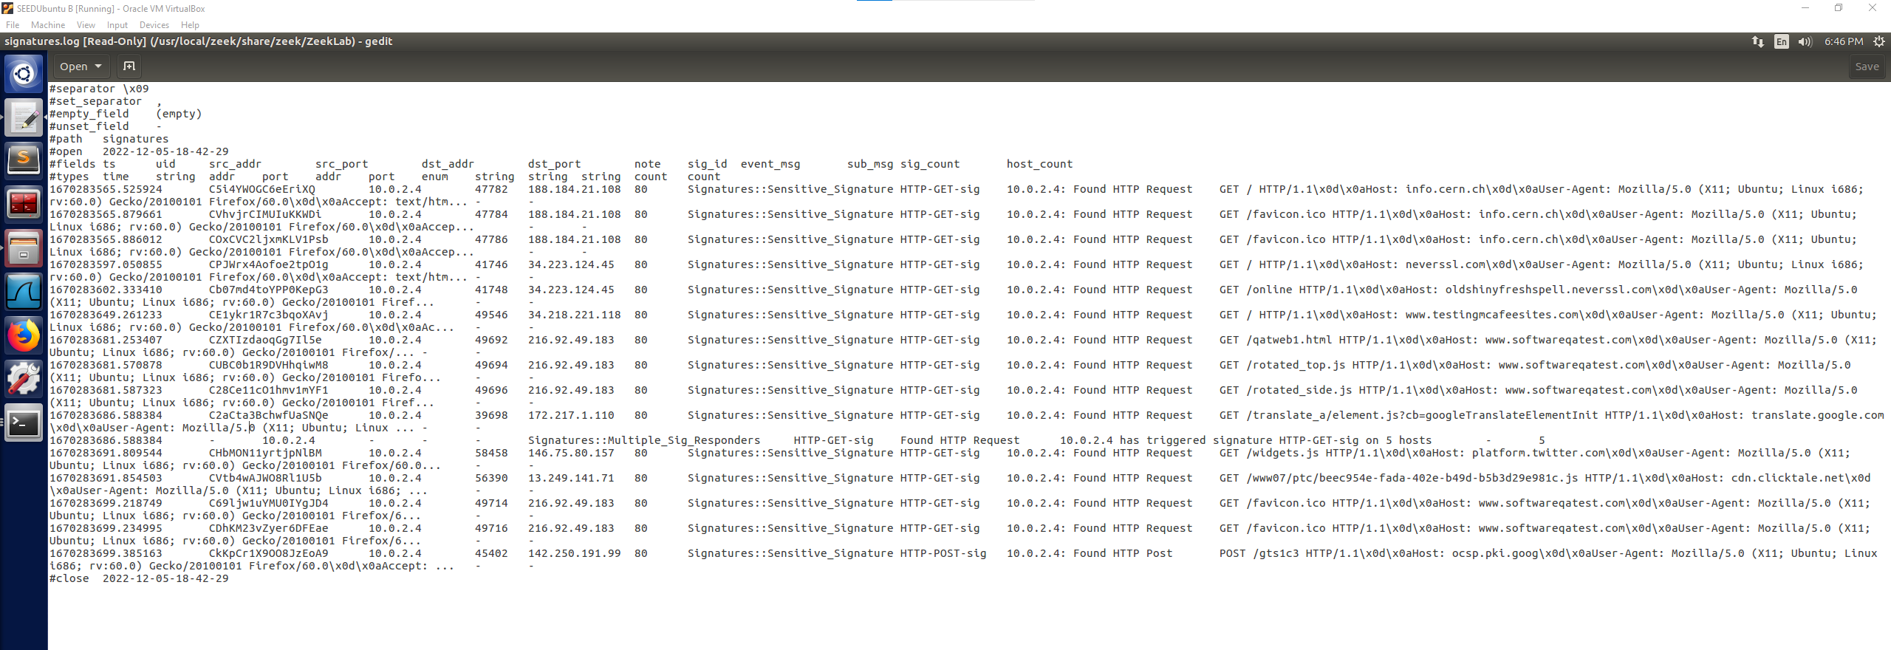

The screenshot shows the logged information about the http websites that were visited in the browser while the zeek script was running. The logged information fits the http1.sig script that was also ran where we wanted to filter out port 80, as seen in the screenshot above all of the connections logged have port 80. The event logged from our script is also seen in the log as “Found HTTP Request” meaning that an http tcp port 80 event was found and then logged.

The connections logged fit with the websites that I had browsed to when looking for http connections. Such as when browsing to softwareqatest.com, which is shown in the log to have an IP address of 216.92.49.183 and is connected to through port 80.

An interesting observation that I noticed in the log was attributed to a twitter widget on one of the pages which produced its own line in the log file despite not being directly navigated to as the webpage that it was located on.

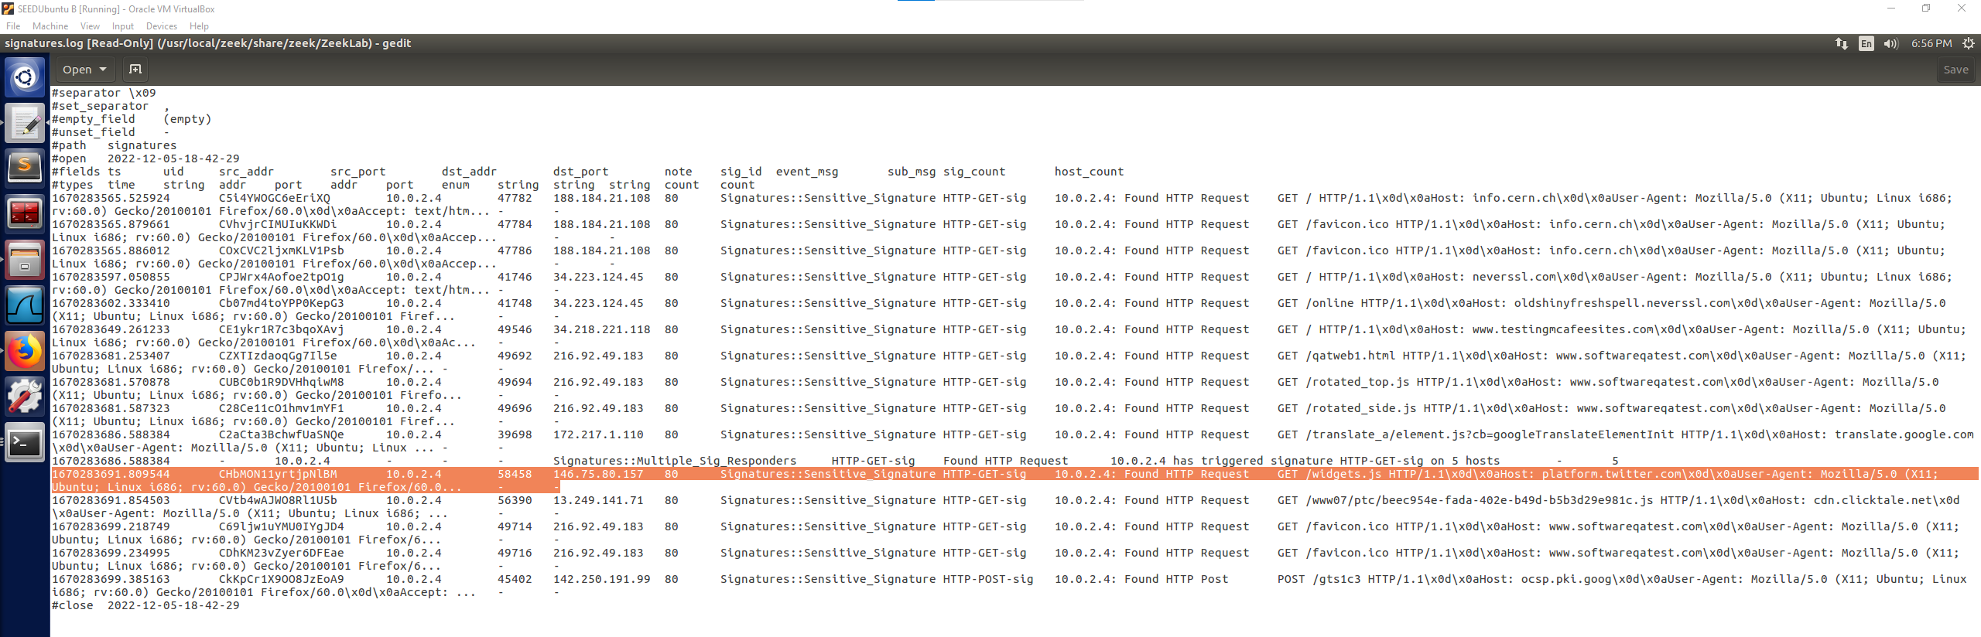

There also was a line that is highlighted below that I thought was interesting because it was the only one that did not present the same information as the other http websites that were navigated to. This one logged as having multiple sig responders and trigged the HTTP-GET event on 5 hosts. I am not sure if that means that it was a printout on the status of logging and that the following 5 logged connections are attributed to that line.

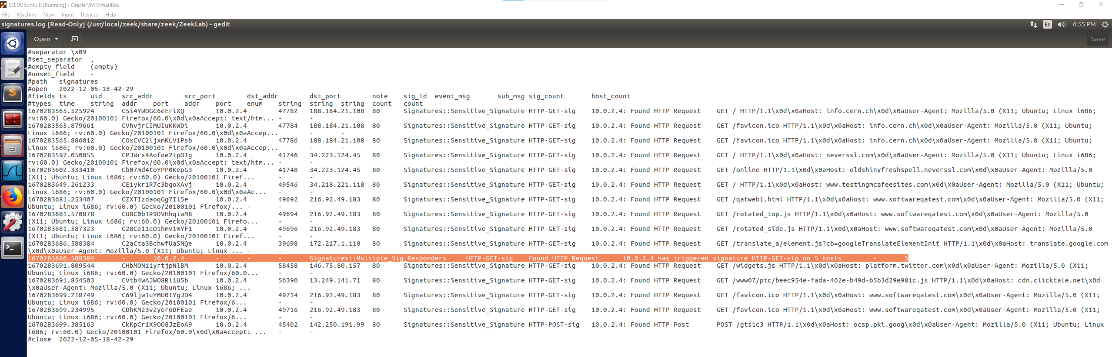

The UID are also still shown with these connections so I believe the user would be able to look in the other log files searching for the UID of one of these connections to find any other additional information on that connection.

The signatures.log file shows the websites that were visited such as softwareqatest.com, testingmcafeesites.com, info.cern.ch, and oldshinyfreshpell.neverssl.com. All of these visited websites were logged amongst other traffic, and then using the signature file we created we were able to process the net_traffic.pcap file to create the sigantures.log file. This log file now contain the http connections that used port 80 and prints out the event of Found HTTP Request. This log contains the source port, destination port(80), source IP address, and destination IP address. By using this signature file we were able to separate out the specific http signature requests from the other traffic that was logged by Zeek.

One last interesting aspect that I noted about the signatures.log file was that the last logged line had Found HTTP Post as the even rather than the request and the IP address belongs to <https://google.com>. This is different than the other logged lines being the only post that was logged and since google is an https I would not have expected it to be logged in with the http connections.

